Answer 4
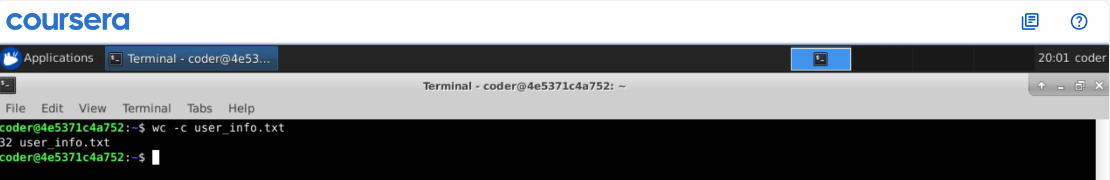
Explanation: Using wc -c user_info.txt, it gives the total character count inside the file with the file name. Running wc without option c will give total character count, line count and word count with the file name.

